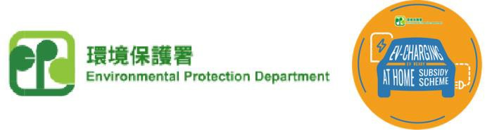
Sample

EV-charging at Home Subsidy Scheme (“EHSS”)
Tender Notice

____________________Building (name of building/development)*
Address：________________________________________ (address of building/development)*

This building/development now sincerely invites participation to this open tendering exercise from registered electrical contractors who possess the relevant engineering works experience and professional qualifications as required by the “Guidance on Preparation of Specifications for Employment of Consultants and Contractors for Installation Works under the EV-charging at Home Subsidy Scheme” issued by Environmental Protection Department.

This building/development has issued the above-mentioned tender on the EHSS Open E-tendering Platform administrated by the Urban Renewal Authority (“URA”). Registered electrical contractors who are included in the Consultants List and / or Contractors List on the Open E-Tendering Platform can visit the following website or scan the “QR code” with your mobile phone to sign in the Open E-Tendering Platform to obtain the relevant information of this tender:
https://openet.brplatform.org.hk/EPD/en/index.aspx | or
Related Information of this Tender is as follows:
1) | Tender Subject | : | __________________________________ EV charging-enabling infrastructure (Project name)* (Examples: Employment of a consultant for design and supervision of installation of / Employment of a contractor for installation of)*
2) | Tender download  period | : | FromClick or tap to enter a date. to on or before Click or tap to enter a date.  Choose an item.(From tender publication date to tender closing date)*
3) | Tender collection  start date and time | : | FromClick or tap to enter a date. Choose an item. to on or before Click or tap to enter a date. Choose an item.  (From tender collection start date to tender closing date)*
4) | Tender collection address |  | Please submit the returned tender to ___________________________________ (Tender collection location)*;  [Tender collection time : 10:00 a.m. to 5:00 p.m., Monday to  Friday (except Saturdays, Sundays and public holidays)]  (Date and time can be adjusted)*
5) | Tender closing date  and time | : | Click or tap to enter a date. Choose an item.
6) | Remarks | : | If you are an electrical contractor included in the register of registered electrical contractors kept by the Director of Electrical and Mechanical Services under Regulation 10(1) of the Electricity (Registration) Regulations (Cap. 406 Sub. Leg.), you can apply for including the name of the company in the Consultants List and / or Contractors List on this open e-tendering platform so as to receive new tender notices. If you are a registered electrical contractor and have not applied for inclusion in the Consultants List and / or Contractors List and have interest in participating in the tender exercise, you may visit the above website to complete the application as soon as possible. Since the application reviewing process takes time, please reserve enough time to apply for an application. In general, the URA will complete processing of the application within 7 working days after the registered electrical contractor submits all required documents and information.

Incorporated Owners of _______________ (name of IO)* / ____________________ (name of DMC Manager)*
*Please delete all the purple notes before publishing this Tender Notice
_________________ (issue date)*

